McDonald’s Lease Transformation

Overview of Bulk Index Adjustment

April 4, 2017

# **Purpose**

This document summarizes how to update index calculator(s) using the Bulk Index Calculator utility.

# **Bulk Index Adjustment Process Flow**

High level summary of the bulk index adjustment process is shown in the process flow below:

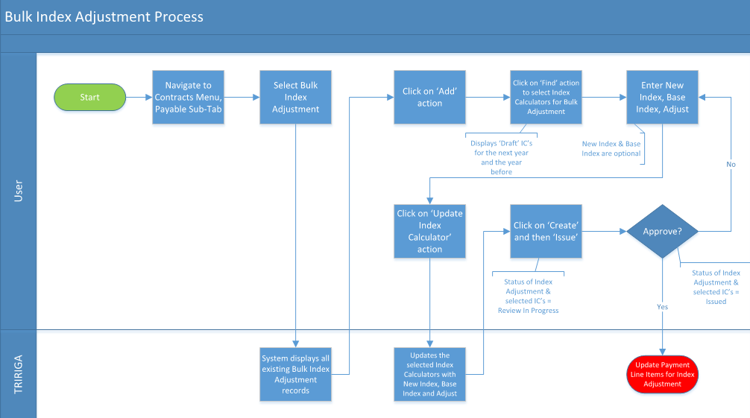

# **Detailed Process Steps**

1. Navigate to “Payables” sub-tab in “Contracts” menu (i.e **Contracts > Payables**) and click on “**Bulk Index Adjustment**” to access Bulk Index Adjustment utility

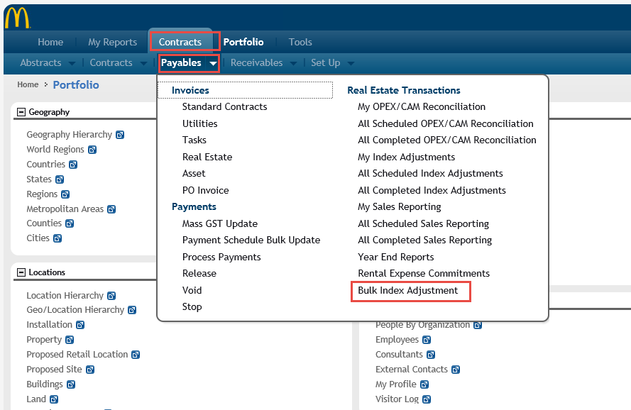

1. Click on “**Add”** to create a new bulk index adjustment for index calculators

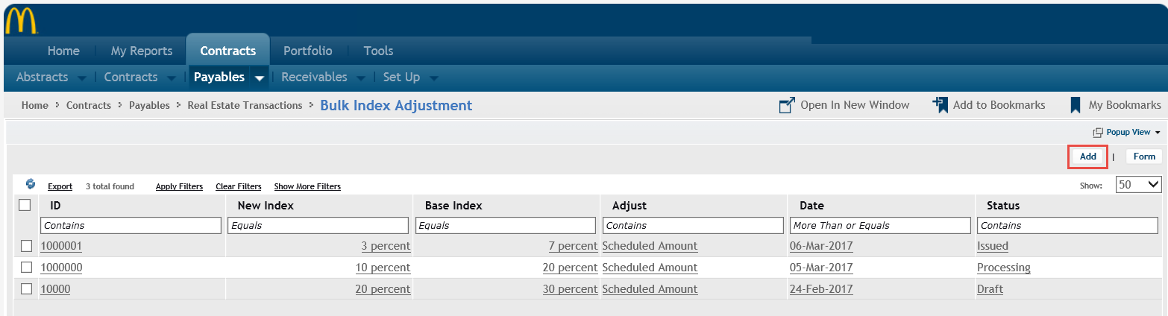

1. Click on “**Find**” and enter applicable search criteria (e.g. Contract ID, Contract Name, Payment Type, etc.) to find the specific index calculator(s) that need to be updated. “Find” will display list of outstanding calculators that are in draft status for prior year and the next 1 year

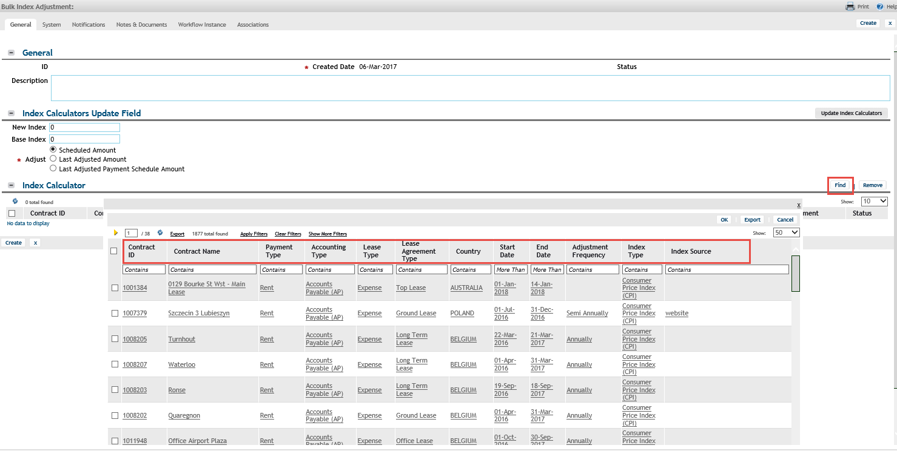

1. Enter the “Index Calculators Update Field” parameters that need to be updated e.g. New Index, Base Index, and Adjust type. Then, click on “**Update Index Calculators**”

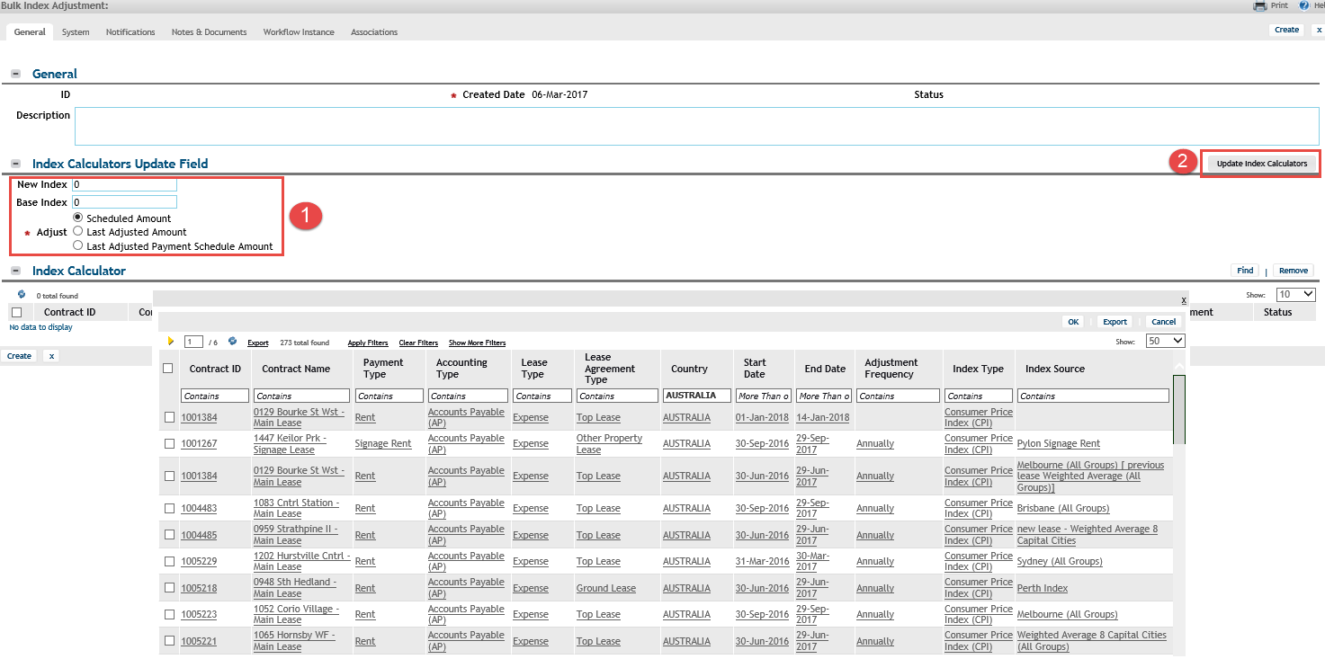

**Note**: One of the 3 adjustment types is required in order for bulk index adjustment to calculate the next rent payments:

* **Scheduled Amount**: Uses the amount from the payment schedule as the basis for the adjustment
* **Last Adjusted Amount**: Uses the adjustment amount from the most recently updated payment schedule as the basis for the adjustment (e.g. if 2016 was first updated, followed by 2012 payment schedules, the 2012 amount will be used)
* **Last Adjusted Payment Schedule Amount**: Uses the adjustment amount from the most recently updated payment schedule year as the basis for the adjustment (e.g. if 2016 and 2012 payment schedules were updated, 2016 amount will be used because that is the most recent year)

1. Click on “**Create**” for the index adjustment parameters to be created for the selected index calculator(s)

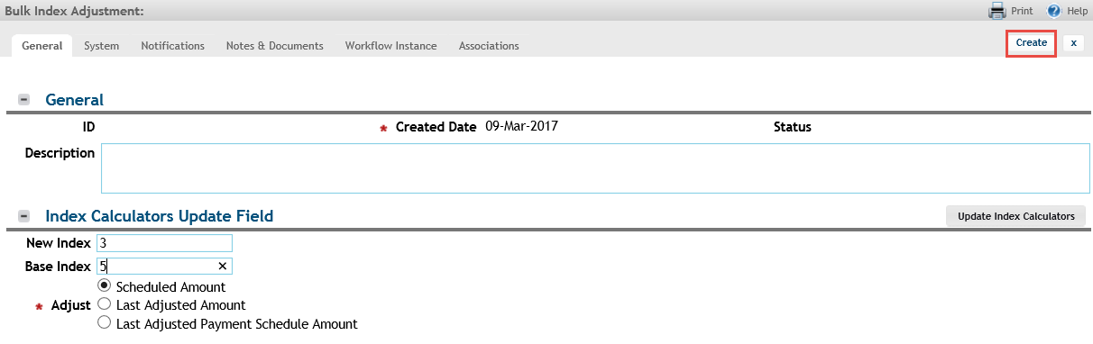

1. To complete the bulk index adjustment process, click on “**Issue**”. This will trigger an approval process for the updated index calculator(s). Once the update is approved, the status of the Bulk Index Adjustment will change to Issued and the applicable PLIs will be updated

